**THERAPY SESSIONS SCHEDULER DOCUMENTATION**

**DESCRIPION:**

This apps main role is to help facilitate the connection between therapists and clients. On this application, therapists will register themselves and clients will be making appointments to different therapists . a therapist will create an account and set his schedule and clients will be able to set appointments on according to hi schedule. On the clients side, a client will make an appointment by choosing a date on which he or she wants to go for therapy and in return will receive an email with a tracking id to keep track of his appointment. The therapist will then approve the appointments that clients made.

Models used:

|  |  |
| --- | --- |
| **Model** | **Attributes** |
| Therapist Credentials | * Id(PK)* * Username(Unique)* * Password* * Email* |
| Therapist description | * id(PK)* * TherapistId* * FirstName* * LastName* * Address* * PhotoUrl* * Description* * Specialty* * Pricing* |
| Therapist Schedule | * Id(PK)* * TherapistId* * Date* |
| Appointment | * Id(PK) * Firstname * Lastname * TherapistId * TherapyId * AppointmentDate * ClientEmail * Message * Status(default: pending) * TrackId |
| Therapies | * Id(pk)* * specialty(Unique)* * image_url* * description* |

In addition to these model there is another model for “LoggedInUser” which will handle logged in users and keep track of when a user is logged in or not.

**Project Planning**

Planning and Design

-gathering information on what therapist do, what types of therapy there is, who seeks therapy and why therapy is need.

-planning out a design for the project (I used figma)

-selecting technologies:

React Js: frontend

SpringBoot: backend

Mysql: persistence

-tools used:

-intellij IDEA 2022.2 ultimate

-Vs Code

-xampp,mysql workbench

-Postman

Development

The development was done starting with the backend and by designing the database schema it involved a lot of learning and applying.

Stages in development

* design schema
* write models
* persist models using spring data jpa
* creation of services
* creation of controllers
* testing in Postman
* developing the view with react js.

Testing

All the testing was done in postman before then making api request to the backend in spring boot using axios in react js.

**Database Schema**

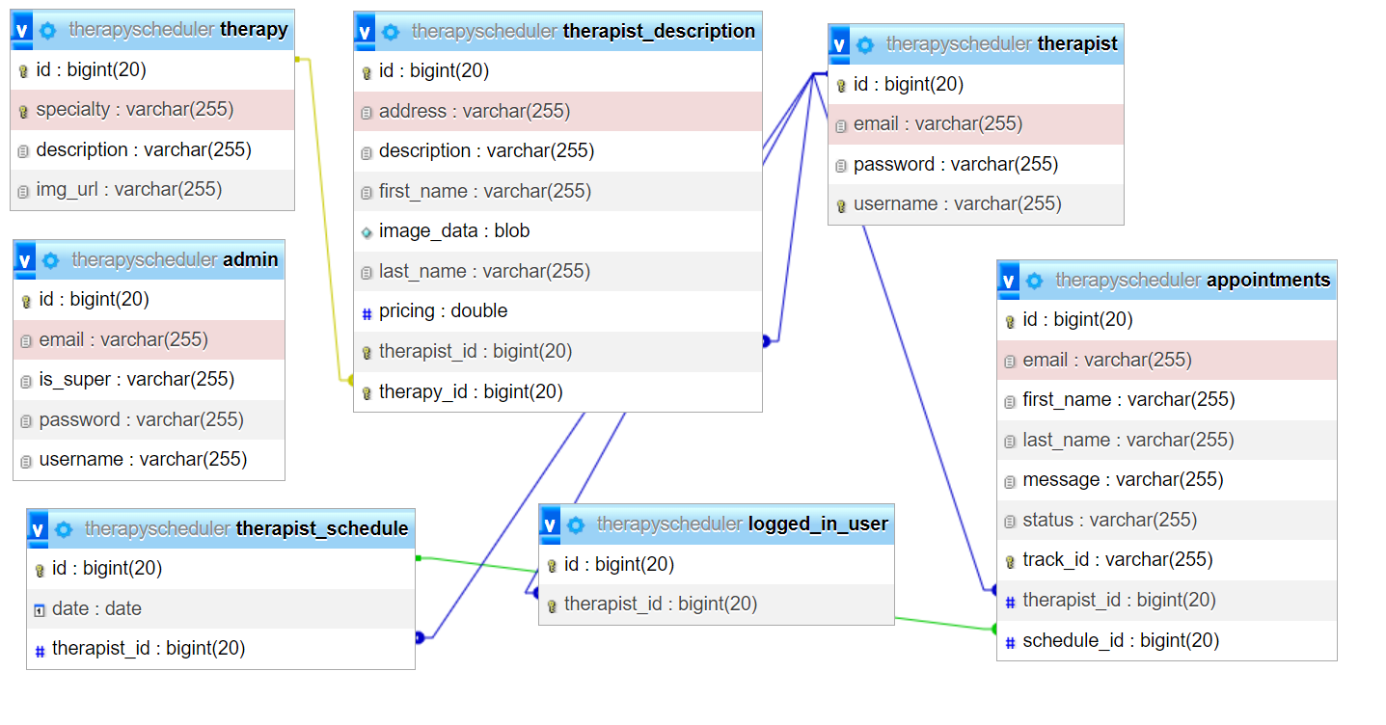

FEATURES

1. Therapist Registration
2. Email sending
3. Schedule setting
4. Appointment making
5. Appointment tracking

After therapist registration the therapist creates a profile and can be seen in the therapists